**Notes to create a website (Basics)**

Html:

- Basic structure of creating a website

- HyperTextMarkupLanguage

- Using HTML, you can add headings, format paragraphs, control line breaks, make lists, emphasize text, create special characters, insert images, create links, build tables, control some styling, and much more.

Css:

- are used to design background, slick images and nice fonts

Javascript:

- is the language that interacts with the users

- it places stuff like security password

**HTML(Overview) PART 1**

The DOCTYPE declaration defines the document type to be HTML

The text between <html> and </html> describes an HTML document

The text between <head> and </head> provides information about the document

The text between <title> and </title> provides a title for the document

The text between <body> and </body> describes the visible page content

The text between <h1> and </h1> describes a heading

The text between <p> and </p> describes a paragraph

Example:

<!DOCTYPE html>

<html>

<head>

<title>Page Title</title>

</head>

<body>

<h1>My First Heading</h1>

<p>My first paragraph.</p>

</body>

</html>

**Hence, the order come in terms of DOCTYPE, html (start), head (inside got title) (start and end) , body (start and end), html(end)**

**HTML Editors**

* Write in notepad and save them as index.html or any other name with name of htm or html.
* Open with chrome from the notepad file

**HTML Basic**

* In the html , there are several subheadings like paragraph and headings which are located in the body
* If you are interested in inserting a title, then you will insert it before the body.
* To **insert link in html**, it is defined with <a>

Eg. <a href="http://www.w3schools.com">This is a link</a>

* To have html images, you will have to also include several information like source file (**src**), alternative text (**alt**), and size (**width** and **height**) are provided as **attributes.**

**Eg.** <img src="w3schools.jpg" alt="W3Schools.com" width="104" height="142">

**HTML Elements**

* Another unique element is <br> which means line break, there is no end element for it.

**HTML Attributes**

* To declare the language attribute, we will write in this form: <html lang=”en – US”>
* If you want to bold the words, place in after the paragraph(b) and (/b)
* For images, there is also an alternative text if no image is shown

Eg. alt=”xxx”

* If you want to **add a title attribute** to the paragraph,

Eg. <a href="http://www.w3schools.com">This is a link</a>

Eg. <p title="About W3Schools">W3Schools is a web developer's site.</p>

**HTML Headings**

* <hr> means a horizontal line
* Head is inside the html but before the body, it contains the meta data which will not be shown

**HTML Paragraphs**

* <pre> and </pre> is the preformatted form which means that all the spaces are followed but html usually doesn’t follow it.

**HTML Styles**

* style="property:value;" (this is the format for the html styling)
* <body style="background-color:lightgrey;"> (Background color)
* <h1 style="color:blue;">This is a heading</h1> (Text color)
* <h1 style="font-family:verdana;">This is a heading</h1> (HTML text font)
* <h1 style="font-size:300%;">This is a heading</h1> (HTML font size)
* <h1 style="text-align:center;">Centered Heading</h1> (HTML text alignment)

**HTML formatting**

* Italic and emphasise is the same thing (is either i or em)
* Strong and bold is the same also (strong or b)
* Smaller text as compared to the rest (small)
* Highlighted Text (marked)
* Underline text (ins)

**HTML Quotations**

* If you plan to cite from a source, must include the source of the cite

**HTML computercode**

* <kbd> is keyboard input from the computer
* <samp> is the computer output
* <code> represents the program code
* If you want to have the line and spaces indented like before, place the <pre> before the <code>
* <var> represents a variable

**HTML Comments**

* To place a comment inside a html code

Eg. <!-- This is a comment -->

**HTML COLORS**

* rgb(red, green, blue), each color is from intensity 0 to 255

**HTML PART 2**

**Styling with CSS**

* Styling can be done in 3 ways which are inline, internal and external.
* **inline styling** is styling for a single element, this is done in the body
* **internal styling** is different. All is done in the head, before writing the body.
* **external styling** is to style for many pages, and usually people includes a reference to find the styling
* font family (is the type of writing), font size is in terms of percent
* CSS Box model (border: 1px solid black, padding: 10px (is for in between the word and the box), margin is for the placing in the page)
* **Id function in CSS** is like making an attribute in the head and if the paragraph needs it then indicate

Eg. <p id="p01">I am different.</p>

* Create a class attribute is just making the name like p.error. Hence the class is error.

**Links**

* <a href="http://www.w3schools.com/html/">Visit our HTML tutorial</a>

**HTML TABLES**

* To create a table in html, you first type <tr> which indicates table row, before putting <td> inside it (starting with most basic: <table style=”width:100%”>
* If you want to have border inside the table, then at the start, you will have to include this instead : <table border=”1” style=”width:100%”>

(Border just means that the exterior is highlighted)

* Styling is done before the body in the head…. table, th, td { border: 2px solid black;}
* Options are available to:

1. collapse the border
2. increase padding(space between them)
3. establish table headings(put <th>, they are automatically highlighted and bold)
4. text align
5. If heading spans more than 2 columns => **<th colspan="2">Telephone</th>**
6. Caption in the table if necessary

**Listing of items in HTML**

* Unordered list includes that of <ul> and the list starts with <li>
* <ul style="list-style-type:disc">
* For ordered list, it starts with <ol> instead of <ul>
* <ol type="i">
* To have a description list, follow the structure.

**HTML Block**

* <div> is the block level element, which makes a part becomes a block

**HTML Classes**

* Allows the possibility to have multiple blocks to exist in a single page
* To have a common style, do it in the head, whereby you type: div.cities{…..}

**HTML LAYOUT**

* it has different layout for html5
* 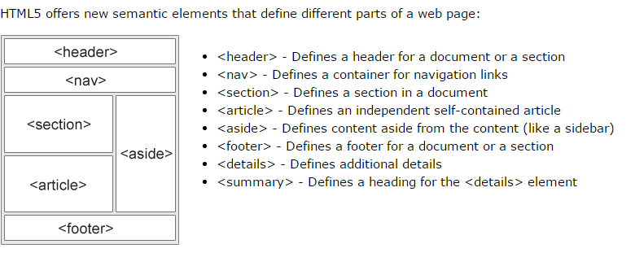
* <div id="header"> to start the different headings

**HTML Responsive webpage**